**Laporan Tugas Kecil 1 Strategi Algoritma IF2211**

Zayd Muhammad Kawakibi Zuhri

13520144

**1. Algoritma *Brute Force* untuk *Word Search Puzzle***

Setelah membaca word search puzzle dari file, grid word search akan disimpan dalam matriks karakter dan kata-kata disimpan dalam array string. Algoritma yang saya buat akan mengiterasi setiap kata dalam array tersebut, dan mencari setiap kata satu-per-satu. Untuk setiap kata, algoritma memeriksa karakter-karakter dalam grid word search mulai dari baris pertama kolom pertama, baris pertama kolom kedua dan seterusnya. Karakter-Karakter tersebut dibandingkan dengan karakter pertama dalam kata yang sedang dicari. Jika tidak sama, akan lanjut ke kolom atau baris selanjutnya. Namun, jika karakter sama dengan karakter pertama kata, algoritma akan lanjut ke pengecekan selanjutnya.

Sesuai aturan word search puzzle, kata dapat terbentuk ke semua 8 arah. Karena itu, algoritma mengecek mulai dari karakter di kiri atas karakter yang tadi ditemukan. Jika karakter di arah tersebut tidak sama dengan karakter kedua dari kata yang sedang dicari, maka pencarian akan lanjut ke atas, kanan atas, kanan, dan seterusnya ke semua 8 arah, sampai ketemu atau tidak ketemu dan balik ke pencarian karakter lain di grid.

Namun, jika karakter kedua tersebut cocok, algoritma akan melakukan pengecekan lebih lanjut ke arah di mana ditemukan karakter kedua tadi. Karakter selanjutnya akan diperiksa dan dicocokkan dengan karakter di kata yang dicari mulai dari karakter ketiga. Jika ada karakter yang tidak cocok, maka akan balik ke pencarian 8 arah yang tadi dilakukan, ke arah selanjutnya. Namun, jika karakter cocok, akan dilanjut pencocokan ke arah yang sama sampai semua karakter dari kata sudah dicocokkan. Jika semua karakter cocok, maka akan ditampilkan solusi kata tersebut dan algoritma diberhentikan.

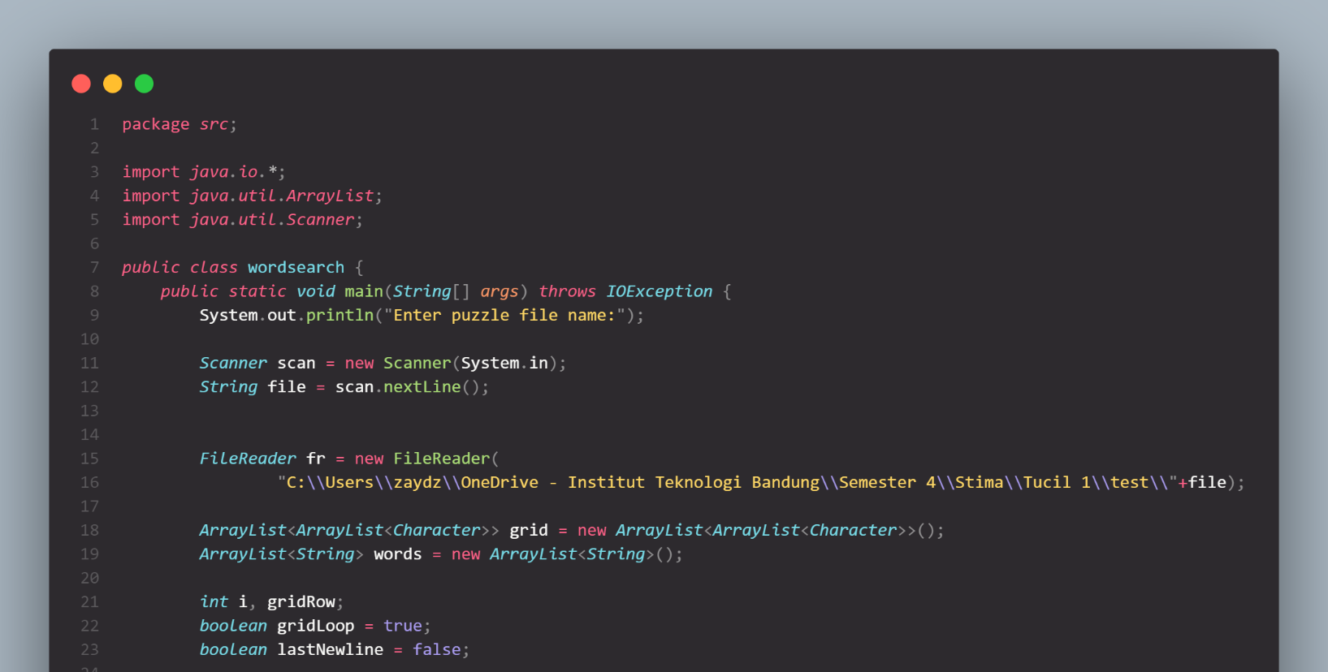**2. *Source Code* (Dalam bahasa *Java*)**

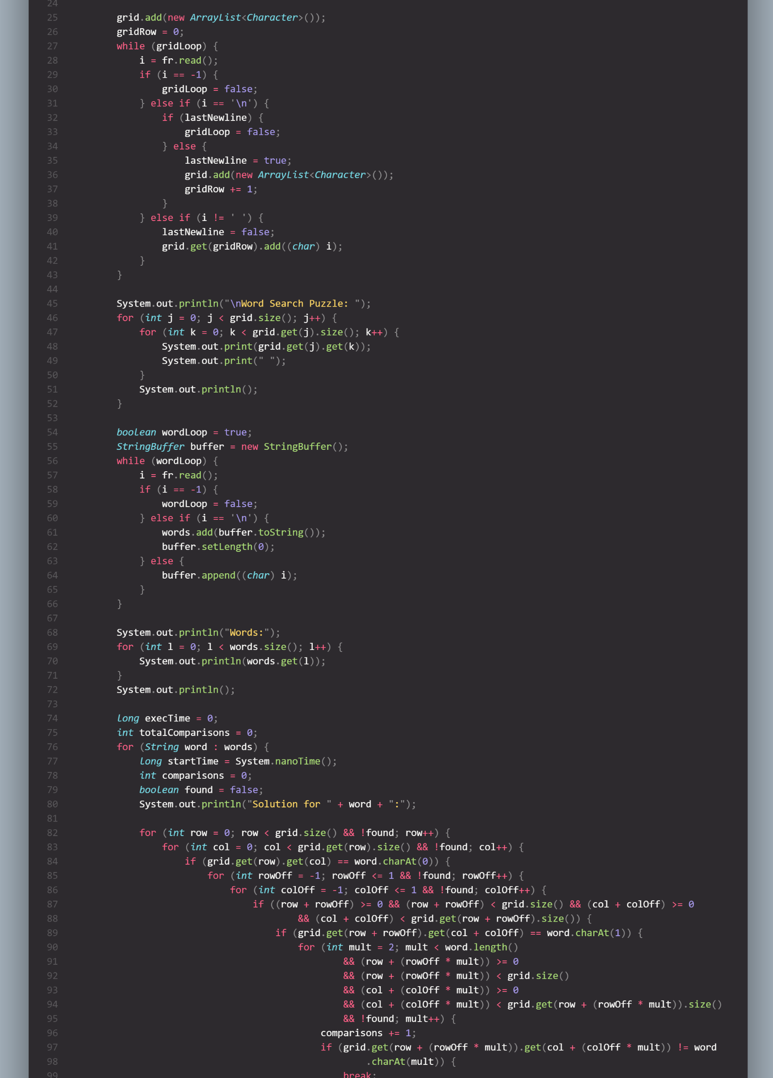

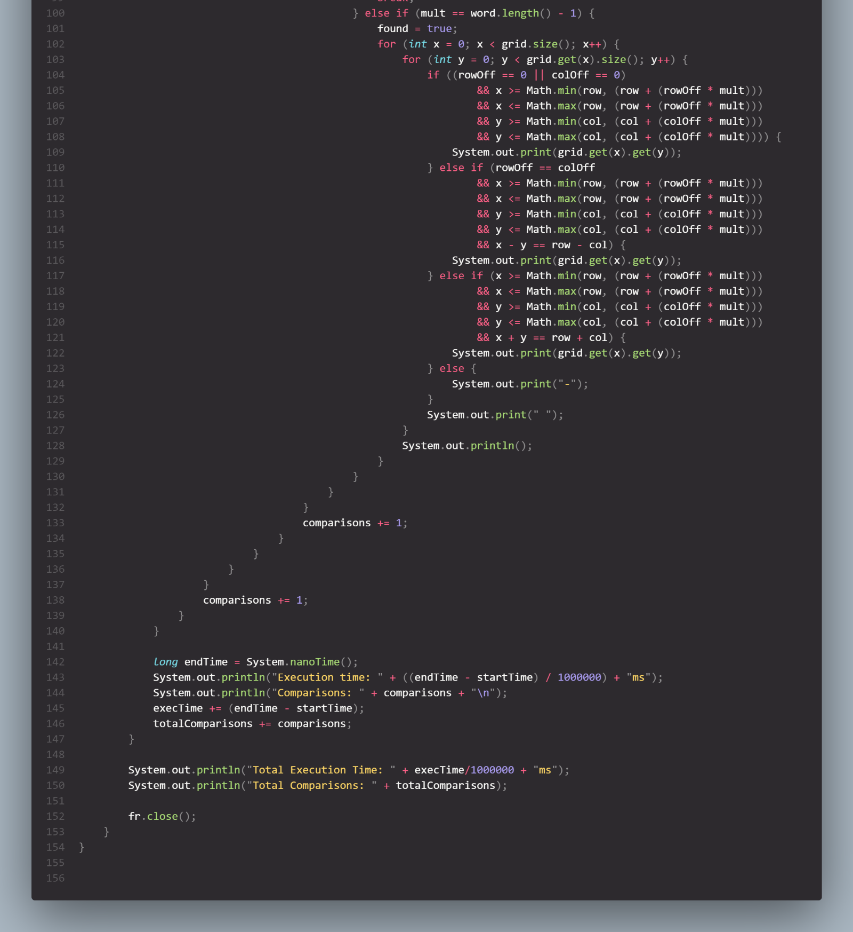

**3. Contoh-Contoh *Word Search Puzzle***

a. Kota-Kota Eropa (Large, 1855ms, 17817 perbandingan)

b. Karakter Genshin (Large, 4006ms, 31719 perbandingan)

c. Bintang (Large, 1583ms, 15107 perbandingan)

d. Konstelasi Bintang (Medium, 1065ms, 10381 perbandingan)

e. English Words (Medium, 583ms, 6364 perbandingan)

f. Kota-Kota Amerika Serikat (Medium, 2060ms, 22994 perbandingan)

g. Planet (Small, 37ms, 363 perbandingan)

h. Karakter Genshin (Small, 423ms, 3408 perbandingan)

i. Bahasa Pemrograman (Small, 116ms, 2117 perbandingan)

**3. Link GitHub *Source Code***

<https://github.com/zaydzuhri/Tucil-1-Stima>

***